ASSIGNMENT ON CAR PARK DESIGN
STUDENT NAME:
INSTITUTION:
DATE:

Deliverable 2
Properties of wood, steel and reinforced concrete
S.no | Material | Tensile strength (Mpa) | Compressive strength
1 | Steel | 315 | 15
2 | Wood | 21 | 31
3 | Concrete | 8 | 43

Stress analysis
The analysis has been done by hand as follows:

Question g.1 and g.2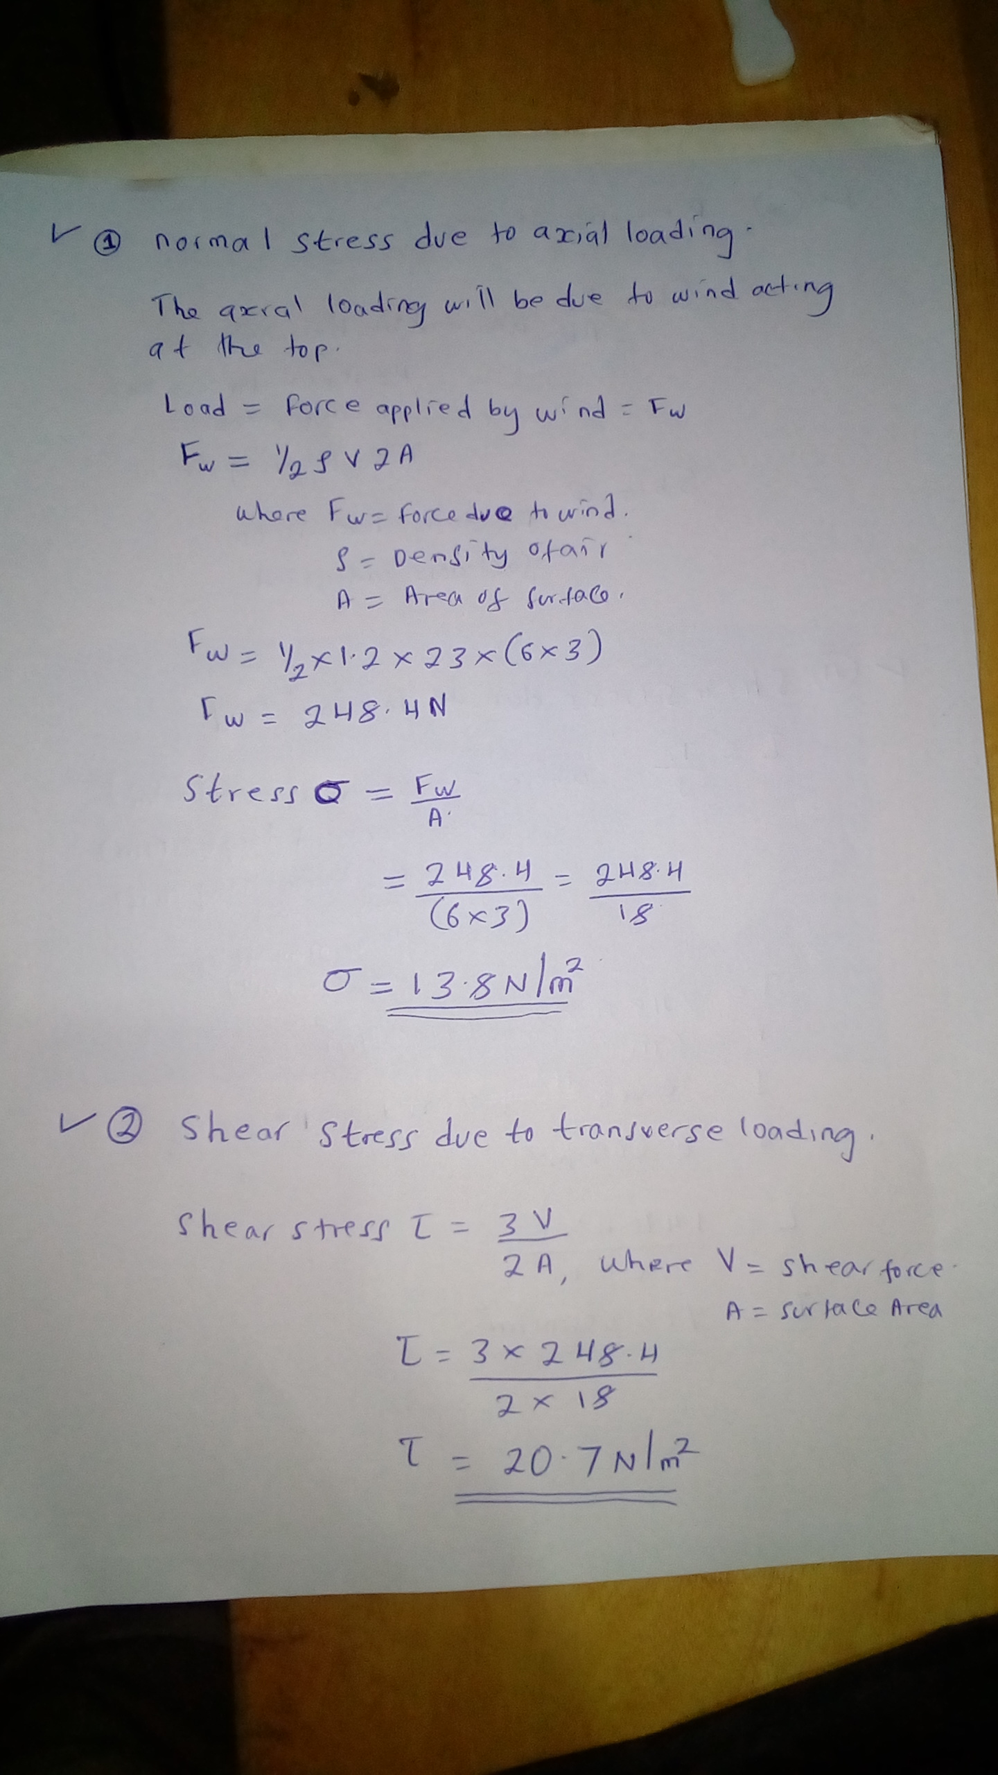

Question g.3 and g.4
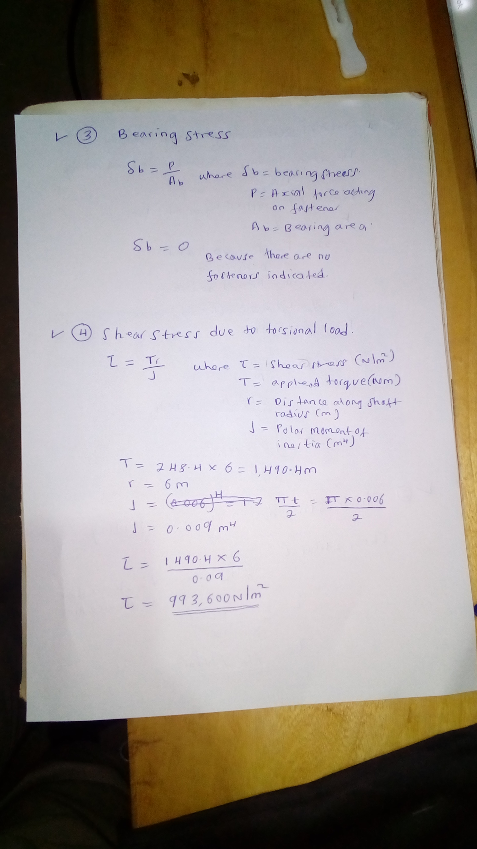

Question g.5
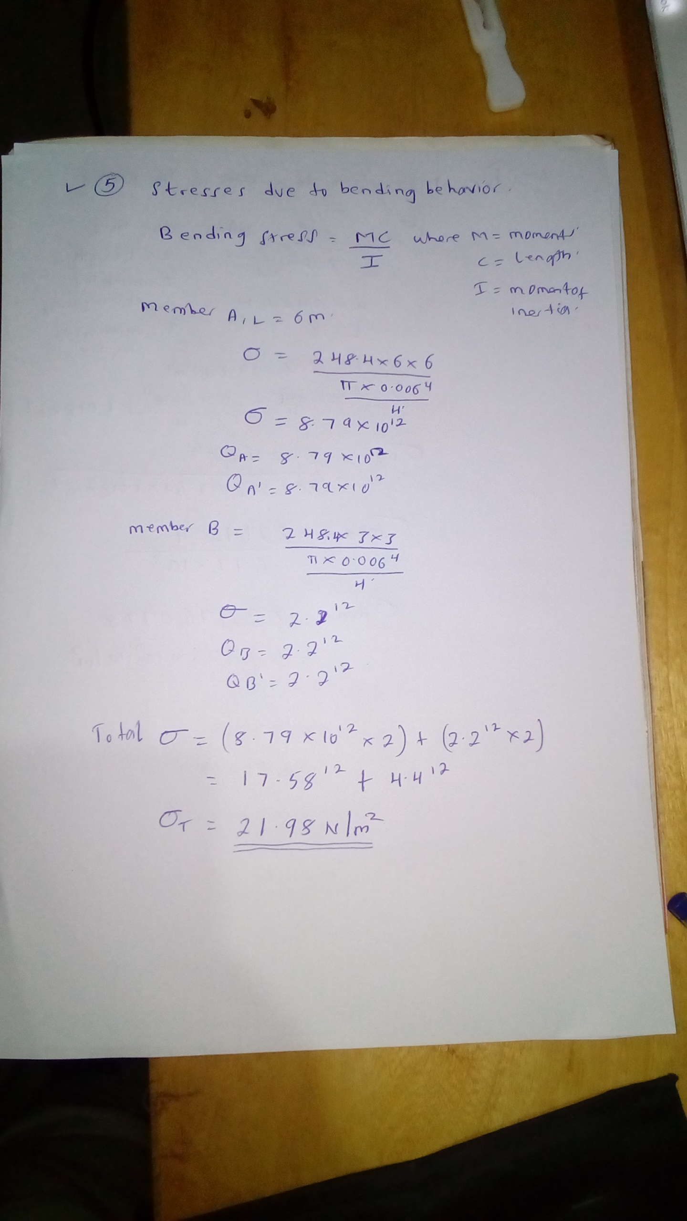

Question h
